INFLUENCE OF THE NON METALLIC INCLUSION ON THE FATIGUE LIFE OF THE VEHICLE SUSPENSION SPRING ACCORDING STEELMAKING PROCESS

Paula, R. F. V (1); Silva, G. M (1); Rausch T. (1); Silva, O. M. M (2);
Sinka, V (3); Hashimoto, T. M (4)

- Mubea do Brasil, Taubaté Av. Eurico Ambogi Santos 2400, CEP 12042-010.
renan.felipe@mubea.com, Gleison.martins@mubea.com; Thiago.rausch@mubea.com
(2) Institute of Aeronautic and Space, IAE, Department of Science and Aerospace
Technology – DCTA.
- School of Engineering – Campus São José dos Campos, UNIVAP – Univ. Vale do
Paraiba / FATEC – Faculty of Technology.
(4) School of Engineering – Campus Guaratingueta, UNESP – Univ. Estadual Paulista.

ABSTRACT

Vehicle suspension springs out of the spring steel SAE 9254, produced with two distinct steelmaking processes, were investigated in order to evaluate fatigue strength performance in regard to the fatigue fracture origin. SEM analyses revealed the fractures were originated from non-metallic inclusions. Several characteristics of the non-metallic inclusions were evaluated, such as size, distance between inclusion center position and wire surface and its chemical composition. As a result of this experiment, springs produced with continuous casting process presented higher number of cycles than springs produced with ingot casting process.

Keywords: non-metallic inclusions, steel cleanliness, fatigue life, steelmaking process.

1. INTRODUCTION

Automotive manufacturers demand their suppliers to develop lightweight and more efficient components, aiming at function improvement, cost reduction and more environmental friendly vehicles. Against this background, suspension springs are also focus of several studies.
In order to achieve vehicle manufacturer’s optimization targets, also offering cost advantages, spring manufacturers invest increasingly in research and development of new process technologies, also requesting from steel maker cleaner wire rods, also regarding inclusion presence, size and location. To offer lighter and more efficient suspension springs, higher fatigue strength must be available, also as a result of the steelmaking process. It is well known that the non-metallic inclusions are the main reason for reduced spring fatigue life, inducing spring failure. Non-metallic inclusions cannot be totally eliminated from the raw material, so it is necessary understand better their influence on suspension springs fatigue life. The objective of this research job was to classify and correlate non-metallic inclusion characteristics in regard to two distinct steelmaking process and suspension spring fatigue life.

2. MATERIALS AND EXPERIMENTS

In Fig. 1 are shown both steelmaking process flow.
Process #1 (Si killed)
Process #2 (Si killed)
Arc furnace
Ladle furnace
Vacuum degassing
Ingot cast (bloom size: 950 x 950 mm)
Hot scarfing
Billet mil (billet size: 155 x 155 mm)
Grinding on the surface defect
Reheat of billets
Rolling process (wire size: 14,30 mm)
Stelmor
Blast furnace
LD converter (BOF)
Ladle furnace
Continuous casting
(billet size: 150 x 150 mm)
Grinding 100% of the billet surface
Reheat of billets
Rolling process (wire size: 14,30 mm)
Stelmor

Fig.1. Process flow diagrams of the steelmaking process.

In Tab. 1 are shown material chemical composition specification and the analysis results of the wire rod of both steelmaking processes.

Tab. 1 - Material chemical composition (% mass).
SAE 9254 | C | Mn | P Max. | S Max. | Si | Cr
SAE 9254 | 0,51 - 0,59 | 0,60 - 0,80 | 0,03 | 0,04 | 1,20 - 1,60 | 0,60 - 0,80
Process 1 | 0,53 | 0,63 | 0,015 | 0,010 | 1,42 | 0,61
Process 2 | 0,55 | 0,69 | 0,012 | 0,012 | 1,37 | 0,66

The influence of the killing of steel, dephosphorization, desulfurization, basicity and slag composition were not considered in this research job.
To compare both mentioned steelmaking processes, their respectively wire rod were drawn to a final diameter of 12,40 mm. Subsequently, the spring wires were heat treated (quenching and tempering) increasing material tensile strength. See Fig. 2 microstructures before and after heat treatment process. The mechanical properties of both heat treated wires are shown in Tab. 2.
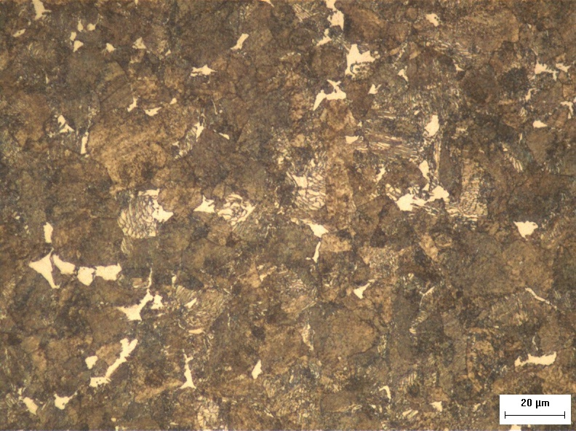
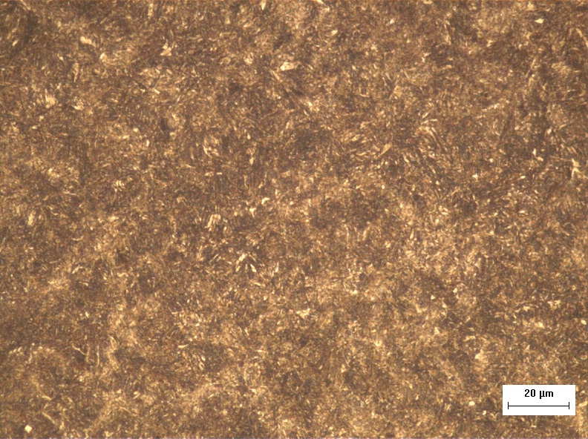

- – Wire rod (Ferrite + Perlite) (b) – Heat treatment (Martensite)
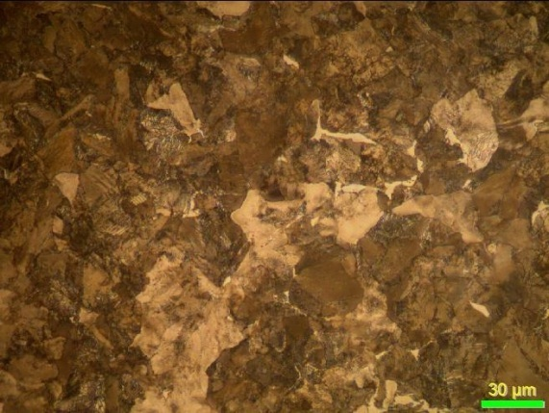
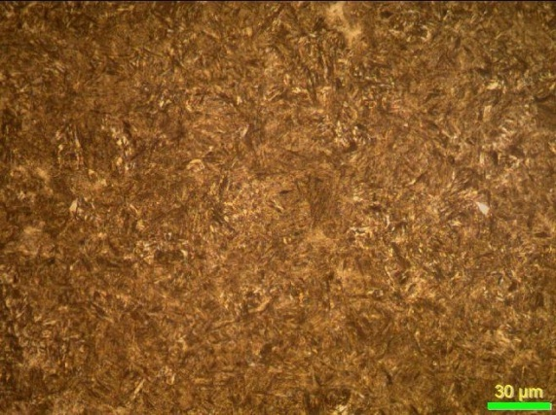

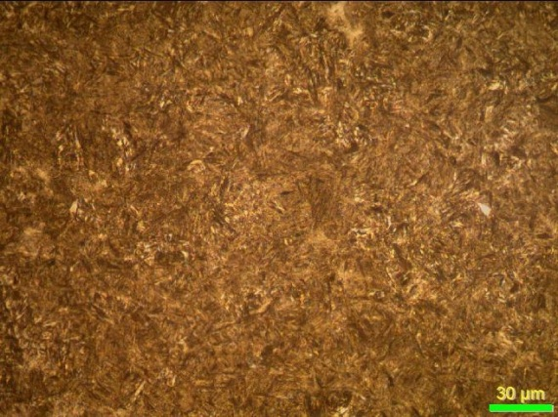

(c) – Wire rod (Ferrite + Perlite) (d) – Heat treatment (Martensite)
Fig.2. Microstructure, (a, b) samples from process #1, (c, d) samples from process #2, (etch: Nital 2% - optical microscope, 500X).

Tab. 2 – Material mechanical properties after heat treatment (Ave. 6 samples).
- | Tensile strength (MPa) | Yield strength (MPa) | Reduction of area (%) | Hardness  (HV2)
Process 01 | 2025 + 3,42 | >1750 | 52,7 + 1,9 | 601,9 + 7,2
Process 02 | 2020 + 5,20 | >1750 | 49,4 + 1,0 | 593,7 + 5,4

After the heat treatment, both final wires show mechanical properties in the same range. Therefore both final spring wires are comparable.
The springs were cold formed to a helical compression spring. After coiling, the springs were submitted to the following production sequence: stress relieving, shot peening and painting. See below spring characteristics:
- number of coils: 7,4
- spring weight: 1,55 Kg
- Rate: 22,5 N/mm,
- Pre-Load: 2.520 N,
See below spring operation conditons:
- maximum stress: 1.026 MPa, minimum stress: 365 MPa
The springs were fatigue tested, simulating the operation conditions assembled in vehicle. The springs were cycled until the fracture with a frequency of 5 Hz in a mechanical fatigue test rig.
It was observed that the stress is usually set to a much lower level than the yield stress. However, even in such cases, the stress can reach values higher than the yield stress at material imperfections and surface defects. In these cases plastic deformation can be induced (1).
It was observed, 80-90% of failures are caused by fatigue. Investigation indicates that almost 100% of these factures start from the sites of stress concentrations at structure discontinuities such as holes, notches, cracks, defects, scratches and also inclusions (2).
It was used a SEM to measure the inclusion size and the distance of inclusions from wire surface. Non-metallic inclusion chemical composition was analysed using EDX.

3. RESULTS AND DISCUSSION

Dimensional analysis of inclusions.

Examining the fracture origin it was observed that most of the springs broke due to inclusions, there was only one spring that broke due to other reason, and was not considered for this study. The fatigue test results are listed in Tab. 3, as well as the size of the inclusion and the distance of the inclusion from wire surface (D.F.W.S).
The non-metallic inclusions are dispersed in the metal matrix. The inclusions present in the metal matrix, result in stress concentration for extinguishing the even distribution of tension. The shape and size of the inclusions have an effect on the stress concentration (3), the Fig. 3 shows example of the inclusion for both process methods.
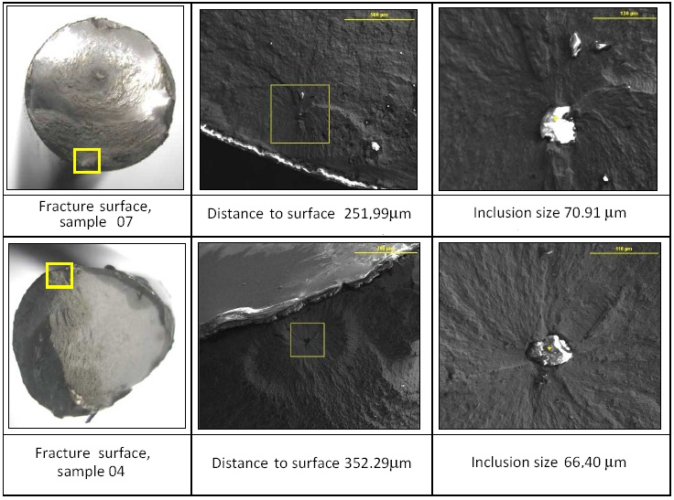
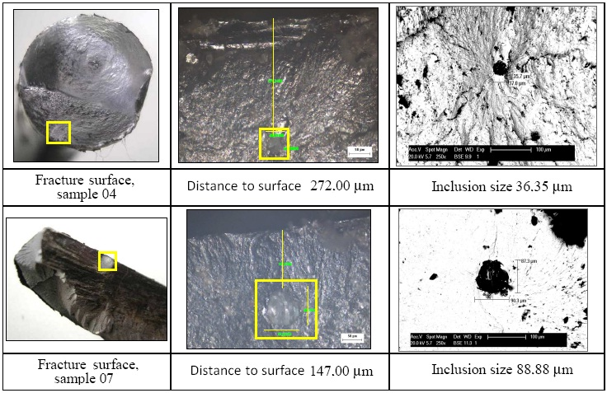

- (b)

Fig.3. Examples of the fracture surface with the initiation inclusion, spring produced from steel meted in electric arc furnace with ingot casting (a) spring produced from steel melted in blast furnace with continuous casting (b).

Tab.3. Fatigue test results, root cause of the breakage, and inclusion characteristics.
Process | Sample | Cycles breakage | Inclusion size (µm) | D.F.W.S (µm) | Oxide | Percentage EDX (%) | I.M.P (ºC)
N#. 1 | 1 | 1.603.020 | 80,61 | 1707,31 | CaO | 58,77 | 1850
 |  |  |  |  | SiO₂ | 24,66 | 1850
 |  |  |  |  | Al₂O₃ | 16,57 | 1850
N#. 1 | 2 | 981.060 | Cavity | 308,26 | CaO | 58,68 | 1850
 |  |  |  |  | SiO₂ | 23,11 | 1850
 |  |  |  |  | Al₂O₃ | 18,20 | 1850
N#. 1 | 3 | 701.040 | Cavity 47,28 | 398,78 | - | - | -
N#. 1 | 4 | 969.500 | 66,40 | 352,29 | CaO | 74,73 | 2200
 |  |  |  |  | SiO₂ | 25,23 | 2200
N#. 1 | 5 | 599.870 | Cavity 114,07 | 951,22 | - | - | -
N#. 1 | 6 | 280.020 | 47,27 | 406,12 | CaO | 56,60 | 1700
 |  |  |  |  | SiO₂ | 43,40 | 1700
N#. 1 | 7 | 299.800 | 70,91 | 251,99 | CaO | 93,20 | 2500
 |  |  |  |  | SiO₂ | 3,77 | 2500
 |  |  |  |  | Al₂O₃ | 3,03 | 2500
N#. 2 | 1 | 930.350 | Cavity  33,20 | 326,00 | - | - | -
N#. 2 | 2 | 2.467.050 | 37,57 | 724,39 | SiO₂ | 100,00 | 1723
N#. 2 | 3 | 2.085.800 | 62,43 | 440,37 | SiO₂ | 87,02 | 1585
 |  |  |  |  | Al₂O₃ | 7,49 | 1585
 |  |  |  |  | MnO | 5,49 | 1585
N#. 2 | 4 | 1.414.087 | 36,35 | 272,00 | SiO₂ | 54,76 | 1400
 |  |  |  |  | Al₂O₃ | 26,75 | 1400
 |  |  |  |  | MgO | 11,60 | 1400
 |  |  |  |  | CaO | 6,89 | 1400
N#. 2 | 5 | 2.165.800 | 40,20 | 592,00 | SiO₂ | 82,83 | 1585
 |  |  |  |  | Al₂O₃ | 9,21 | 1585
 |  |  |  |  | MnO | 6,28 | 1585
 |  |  |  |  | MgO | 1,68 | 1585
N#. 2 | 6 | 2.554.329 | 6,54 | 537,00 | SiO₂ | 51,91 | 1500
 |  |  |  |  | Al₂O₃ | 13,76 | 1500
 |  |  |  |  | MgO | 30,98 | 1500
 |  |  |  |  | CaO | 3,35 | 1500
N#. 2 | 7 | 2.554.813 | 88,88 | 147,00 | SiO₂ | 78,76 | 1585
 |  |  |  |  | Al₂O₃ | 11,34 | 1585
 |  |  |  |  | MnO | 9,90 | 1585
N#. 2 | 8 | 3.865.420 | 59,09 | 562,69 | SiO₂ | 56,16 | 1585
 |  |  |  |  | Al₂O₃ | 5,95 | 1585
 |  |  |  |  | MnO | 37,89 | 1585
The correlation between the size of the inclusion that initiated the fracture and the number of cycles to fracture is represented in Fig. 4a. The springs made from the steel
of process 1 (electric arc furnace with ingot casting process) fractured from bigger inclusions exhibiting lower fatigue life than the springs from process 2 (blast furnace with continuous casting process). It is well known that big inclusions cause more stress concentration, reducing the fatigue life of the material (4).
The influence of the distance between inclusion to wire surface was also evaluated. The results are resumed in Fig. 4b, showing that the springs from process 1 has high variation of the distance between inclusion distance from wire surface (average: 625,14 + 530,84 µm) in comparison to process 2, where the results has lower variation of the distance between inclusion to wire surface (average 450,18 + 190,74 µm).
The material fatigue life is affected due to position of the inclusion at transversal material section, including distance between inclusion to wire surface (5).
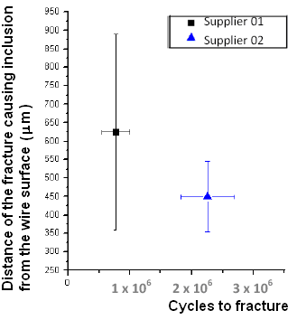
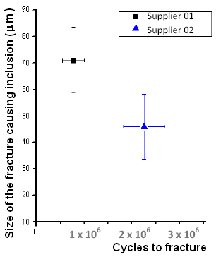
Process 01
Process 02
Process 01
Process 02

- (b)

Fig.4. Inclusion size range versus fatigue cycles (a). Distance between inclusion to wire surface versus fatigue cycles (b).

The inclusions that originated the fatigue fracture were analyzed by EDX in order to determine the type of the inclusion on the basis of the obtained qualitative and quantitative data.
The inclusions can be present in many compositions, but usually for this steel they are oxides (SiO₂, Al₂O₃, CaO, others). Since the EDX cannot identify the compound type, only the elements present in it (Si, Al, Ca, others), so it was considered that the inclusions are formed only by oxides. The percentage of each oxide in the inclusion was calculated on the basis of the EDX results using the equation (A), assuming that all the elements present in the inclusion formed oxides, the results are resumed in Table 3.

Percentage of the oxide elements = A . G (A)

A = percentage of the element identified by EDX analysis
G = a calculated factor: G = (B + C) / B
B = atomic weight of the element detected by EDX to be considered oxide.
C = oxygen atomic weight.
According the results, it was possible to localize the inclusion in the respective ternary phase diagrams (Fig. 5 and Fig. 6) as well as to identify it and determine its melting point (I.M.P), See Tab. 3 the melting point for each inclusion.

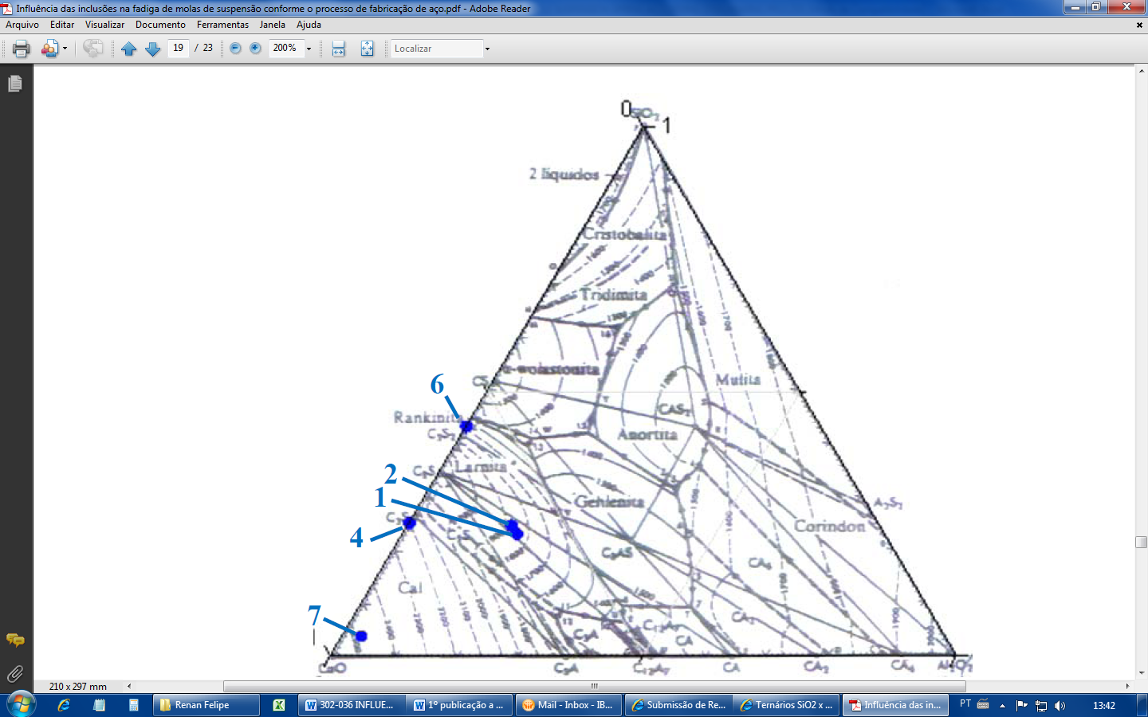
Process 1:

Fig.5. Sample 1,2,4,6 and 7, phase diagram SiO₂ x CaO x Al₂O₃.
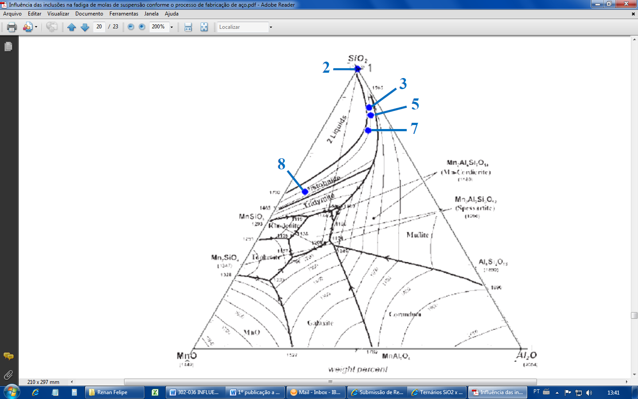
Process 02:

Fig.6. Samples 2, 3, 5, 7 and 8, phase diagram SiO₂ x Al₂O₃ x MnO (b).

A correlation was observed between inclusion size and the inclusion melting point, see Fig. 7. This is happened due to the inclusion deformability during the wire forming process. Inclusion with low melting point deforms more during rolling process resulting in smaller inclusion size than inclusion with high melting point.
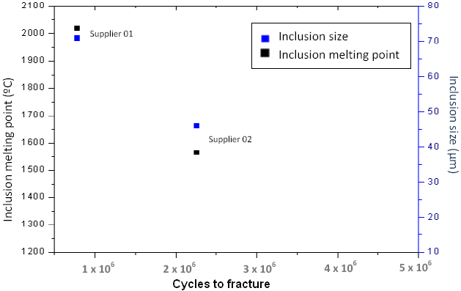
Process 01
Process 02

Fig.7. Correlation between inclusion size and its melting point.
Inclusions with high percentage of Al₂O₃ has high melting point (2050 ºC) but if is add some quantity of SiO₂ and CaO the melting point will be reduced (6).
The same effect happened with inclusion with high percentage of SiO₂, that has high melting point, if add + 20% of Al₂O₃ at inclusion composition the melt point will reduce (7).
The deformability of the inclusions are linked with your chemical composition according Fig. 8.

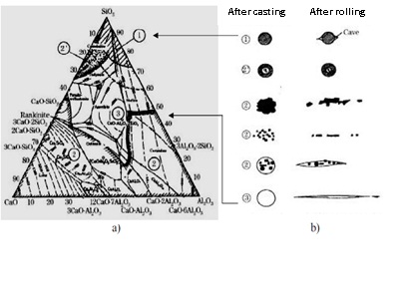
Fig.8. Ternary diagram CaO - Al2O3 - SiO2 (a), showing the regions of the inclusions with their morphology, (b) Morphology of non-metallic inclusions after melting and rolling process, referenced by their region in ternary diagram (7).

The deformability of the inclusion depends on the inclusion melting point, and the material forging ratio (8), the process 01 (electric arc furnace with ingot casting) present more forging ratio than process 02 (Blast furnace with continuous casting), see Tab. 4.

Tab.4. Material reduction area (forging ratio).
Process | Billet size  (mm) | Rolling wire size (mm) | Material area reduced (mm²)
01 | 950 x 950 | 14,30 | 902339,40
02 | 150 x 150 | 14,30 | 22339,40

4. Conclusion:

1. The springs tested in dynamic test from both steelmaking processes broke due to inclusion.

2. The average inclusion size from process 1 is 71,1 + 24,9 µm, bigger than average inclusion size from process 2 that is 45,5 + 24,5 µm. The reflex of the inclusion size in the material fatigue life confirms the literature information. The greater the inclusion size the lower will be the spring fatigue life due to stress concentration at inclusion region. The average fatigue life of process 1 was 776,330 + 460,590 cycles and average fatigue life of process 2 was 2.254,706 + 871,478 cycles.

3. The inclusion size exhibits a correlation with inclusion chemical composition and also inclusion melting point. Inclusions with low melting point are more deformed during rolling process when compared with inclusions with high melting pointing, this affirmation confirm the result found at item 2. Because the inclusion melting point from process 1 is 2020 + 325 ºC higher than inclusion melting point from process 2 that is 1566 + 98 ºC.
The inclusion chemical composition depends on the many factors which were not neither mentioned nore investigated in this study, such as killing of steel, dephosphorization, desulfurization, basicity, slag composition and others, but according to the results related, it can be seen process 1 (electric arc furnace) uses 80 to 90% of scrap to produce pig iron and probably is more complicate to control the inclusion chemical composition than process 2 (blast furnace).

4. A positive characteristic of the ingot casting regarding inclusion deformability was not observed in this study, the forging rate of the billets from ingot casting was much higher than billets from continuous casting, so the inclusions from ingot casting should be more deformed than inclusion from continuous casting, so it is possible to observe that the inclusion melt point has more influence than billet forging rate.

5. It was concluded that the distance of the inclusion from wire surface has effect on the spring fatigue life.
The samples at table 5 (data from table 3) has the same inclusion size and the same inclusion melting point, but the distance between inclusion to wire surface of the sample 8 is 122,32 µm deeper than sample 3, and the effect of this is that sample 8 broke with 1.779.620 cycles longer than sample 3.

Tab.5. Results comparison, distance between inclusion to wire surface.
Process | Sample | Cycles breakage | Inclusion size (µm) | D.F.W.S (µm) | I.M.P (ºC)
2 | 3 | 2.085.800 | 62,43 | 440,37 | 1585
2 | 8 | 3.865.420 | 59,09 | 562,69 | 1585

The process 1 has high variation of the distance between inclusion distance from wire surface (average: 625,14 + 530,84 µm) in comparison to process 2, where the results has lower variation of the distance between inclusion to wire surface (average 450,18 + 190,74 µm). This difference might be justified due to continuous casting has an electromagnetic stirring in the mold, that the objective is homogenize the steel melt chemical composition and avoid inclusions close to wire surface, sending the inclusions to material core, this equipment is not applied in ingot casting process.

5. REFERENCES:

- Murakami, Y. Metal Fatigue: Effects of small Defects and Nonmetallic inclusions, Kyushu University, Japan: Elsevier, 2002.

- McEvily, A.J. Metal Failures: Mechanisms Analysis, Prevention, John Wiley, New York, 2002 and S. Nishida: Failure Analysis in Engineering Application, Butterworth Heinemann, London 1992.

- Martins, S. R. Fatigue life of the valve spring material (SAE 9258), difference between continuous casting process and ingot casting process. 2010. Dissertation (Master degree - Material) School of engineering – Campus Guaratingueta, UNESP – Univ. Estadual Paulista.

- KAWAHARA, J. Advance of valve spring steel. Japan, Nippon Steel, 2000.

- Duckworth W. E; Ineson E. The effects of externally introduced Alumina Particles on the fatigue life of En24 steel, Clean Steel, Iron Steel Inst. Spec. Rep. 77 (1963), 83 – 103.

- PIMENTEL, M. Effect of practice on the preparation of steel internal cleaning of steels for valve spring (SAE 6150 e SAE 9254). Brazil, ABM 54°Congress, 1999.

- LEANDRO, C. Development of SAE 9258 steel spring for dynamic
valve. Brazil, 2006.

- Data sheet: Fatigue strength of steels, High Carbon steels (Material RCC),
Sumitomo Met. 35(3) (1983) 358-361.

