TECHNICAL APPROACH ON Nd-Fe-B MAGNETS PRODUCED VIA POWDER INJECTION MOLDING

A. Owczarzak¹⁾, M. A. Carvalho¹⁾*, L. U. Lopes¹⁾, C. S. Teixeira¹⁾, P. A. P. Wendhausen¹⁾
1) Department of Mechanical Engineering, LabMat - Materials Laboratory, Federal University of Santa Catarina, Campus Universitário Reitor João David Ferreira Lima, Trindade - Florianópolis, SC – 88.040-900, Brazil
*matheus@emc.ufsc.br

ABSTRACT

Powder injection Molding (PIM) is known as an alternative production process that allows the production of ceramic and metallic parts with intricate shapes, small dimensions, and high productivity (4). Permanent magnets are commonly produced via conventional powder metallurgy and may have restrictions in terms of processing, magnetic properties or economic factors. In the PIM process, a feedstock prepared as a mixture between neodymium iron boron (NdFeB) powder and a multi component binder system were injected within a conventional injection molding machine with a special designed mold that allows the alignment of the particles. The injected samples were chemically and thermally debounded and sintered in high vacuum at a temperature of 1080ºC for 1 h. The samples were then characterized in terms of magnetic properties, carbon content and microstructure.

Key Words: Powder Injection Molding, Magnetic materials, Nd-Fe-B

INTRODUCTION

According to Coey (1) permanent magnets have being objects of fascination for millennia, providing revolutions in state ritual and medical quackery, navigation systems, and being responsible for an electronic revolution on data storage systems and it may have a premising new future, with the improvement of electric cars and renewable sources of energy such as wind power.
The Nd based magnets represent an important class of rare earth based compounds representing according to O`Handley (2) the large uniaxial magnetic anisotropy (of the tetragonal phase), the largest magnetization (B_{s} = 1.6 T), and a high stability of the Nd₁₄Fe₂B₁ grains separated to a Boron rich and a Nd rich phases, witch tend to decouple the magnetic grains. According to (1,3) there are three common forms of processing NdFeB based magnets, trough sintering, polymer bounding or hot deformation routes, the first one it is considered the most common because of the simplicity of the process and the easiness to align the c-axis orientation, providing a anisotropic structure with important magnetic properties.
The focus of this paper is to analyze and discuss the Powder Injection molding Process (PIM) to produce this class of material, according to German (4) the PIM consists in involve the powder with a semi-fluid (usually a wax-polymer binder) state compound and shape the product in a thermoplastic injection molding machine, after shaping the binder is removed, usually by heat, or/and chemically and then the structure is sintered like a traditional powder metallurgy product.
The shaping flexibility and complexibility, the productive scale and reproducibility of this process are the keys of understanding the usage of this process and the possibility to apply a magnetic field to align the particles during injection permits the anisotropy and high values of coercivity (H_{cj}) and remanence (B_{r}).

MATERIALS AND METHODS

It was studied a commercially available alloy, with nominal composition Nd₁₇Dy₂B₁₂Co₈Fe₆₁, the feedstock were injected into a specially designed mold the samples were characterized with a hysteresis loop.

Powder preparation
The ingot was pulverized using hydrogen decrepitation (HD), performed at 170± 10ºC at 1 bar pressure and milled in a planetary ball mill under hexane atmosphere for 3 hours with a ball to powder ratio of 10:1 and with a rotational speed of 230 rotations per minute. The powder was characterized using the software ImageJ®, on an scanning electron microscopy (SEM) image.

Feedstock
Feedstock is defined as the mixing of selected powders and the chosen binder system represented 8% weight of the feedstock was composed by 55% of paraffin wax (PW), 30% of high density polyethylene (HDPE) and 15% of ethylene-vinyl acetate (EVA). The components PW and EVA were previously dissolved in hexane and mixed with the milled powder. The pre-mixture was agitated during 30 minutes in a planetary mill with a rotational speed of 230 rpm to get a better powder coating.
The next step is pump out the solvent to get a dry mixture of the binders and the powder and fill it into HDPE bags, and fed into a shear mixer flushed by argon to avoid oxidation. The feedstock mixture was carried out at 150ºC for 30 minutes.

Injection molding
In order to align the particles, the injection molding should be performed under magnetic field trough a special mold. A magnetostatic simulation was designed assisted with the software Maxwell 14®, a coil with 2879 turns, and a 30 mm diameter and 80mm length concentrator, generating a magnetic field of 1 T through a total of 18000 tetrahedral mesh elements and presenting a estimated energy error of 0.77%.
Diverse materials and geometries were projected to enhance the flux concentration on the injection cavity visualizing different gradient fields in the injected samples.
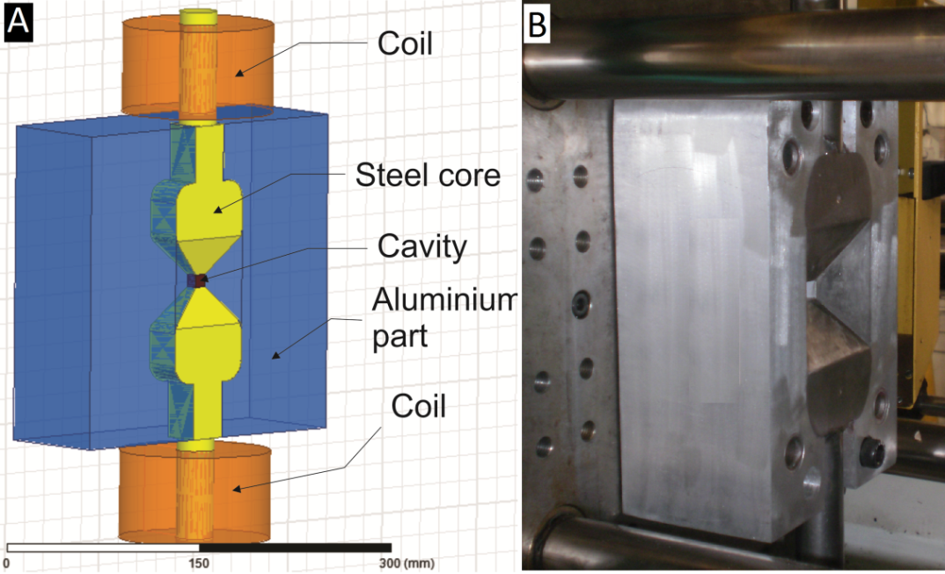
Figure 1 - Injection mold.
The injection process was performed in a 220S ARBURG injection molding machine with an injection pressure of 1x10⁸ Pa at 190 ºC. During the injection a magnetic field of 1 T was applied to align the particles. Scanning electron microscopy were used in order to evaluate the presence of agglomerates and homogeneity of the injected part It was chosen to produce a cubic sample with edges of 10mm.

Debinding
After injection molding the binders are no longer useful, and may cause problems if not carefully removed, like distortion cracking and contamination. On this experiment two steps were used to remove the binders, at first a chemical debinding, immerging the samples on hexane on a temperature between 45 to 55ºC, monitoring the weight of the system until most of the soluble binder fraction was removed.
A second step followed is the thermal debinding, determined by the rate of high molecular weight polymers decomposition, a Thermogravimetric analysis (TGA) was performed to analyse the reaction temperature. A reducing agent (hydrogen flux) was applied during thermal debinding for carbon extraction.

Sintering
The sintering process is necessary to establish on the material a microstructure with high content in magnetic phases. It was performed in afterward the thermal debinding process in high vacuum with a heating hate of 18ºC/minute until 1080ºC. On Figure 2 it is seen the thermal cycle used during the thermal debinding and sintering processes.
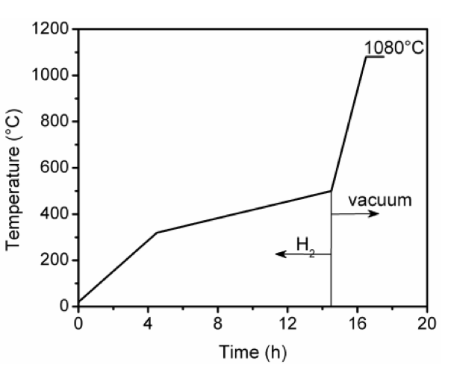
Figure 2 - Schematic diagram of thermal debinding and sintering.

Characterization
The samples were magnetized with a 4,5T pulse on a pulse magnetizer model Globalmag CP2000 and characterized in a Brockhaus Hystograph where the remanence and coercivity were evaluated on the easy and hard magnetize direction. Later a carbon contamination was evaluated by fusion gas analysis and the final microstructure observed on a LECO IR412 scanning electron microscopy.

RESULTS AND DISCUSSIONS

It is shown in Figure 3 the micrograph of the milled powder, it is observed a high irregularly morphology, with particles with different sizes and geometries, analyzing this image with the treating analysis software the estimated particle size is 4.8 μm.
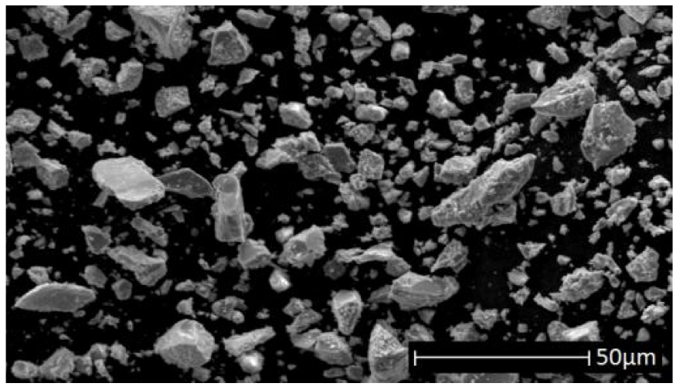
Figure 3 – Micrograph of Nd₁₇Dy₂B₁₂Co₈Fe₆₁ powder.
The injected samples have achieved a bulk density value of 4.7 g/cm³, in Figure 4 it is shown an injected sample, and in Figure 5 the SEM micrograph of the sample`s surface, where it is observed a relatively homogeneous mixture of powders and binders.

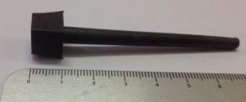 | 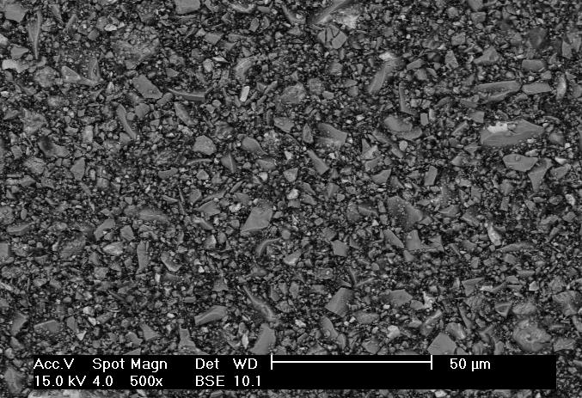
Figure 4 - Injected sample with the sprue. | Figure 5 – SEM of an injected sample surface.
The binder loss could be seen in Figure 6, where almost 95% weight loss of soluble binders was observed after 40h. A micrograph with open porosity is shown in Figure 7 with a SEM analysis of the surface of the sample, as known an open porosity it is crucial for the next debinding step in order to allow the degraded HDPE escape and prevent the forming of distortions, bubbles or cracks (4).
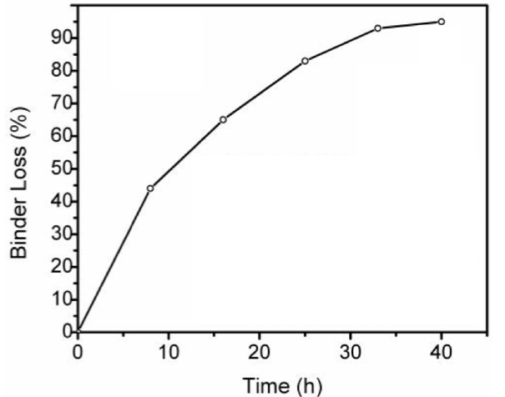 | 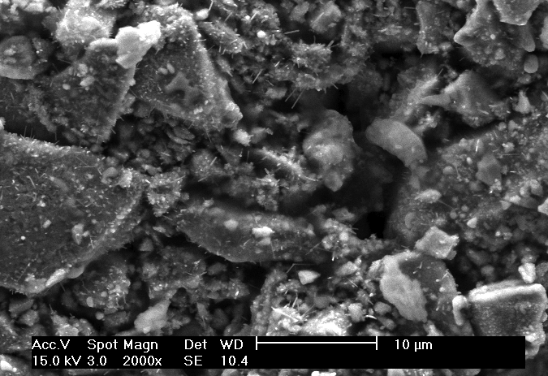
Figure 6 – Binder loss in function of time. | Figure 7 - Resulting microstructure of the chemical debinding.
The thermal debinding cycle, shown in Figure 2, was designed based on TGA analysis, showed on Figure 8 where it can be seeing a significant weight loss (2,4%) at temperature range of 380 to 450ºC. The lost weight is due the decomposition amount of HDPE present in the binder system.
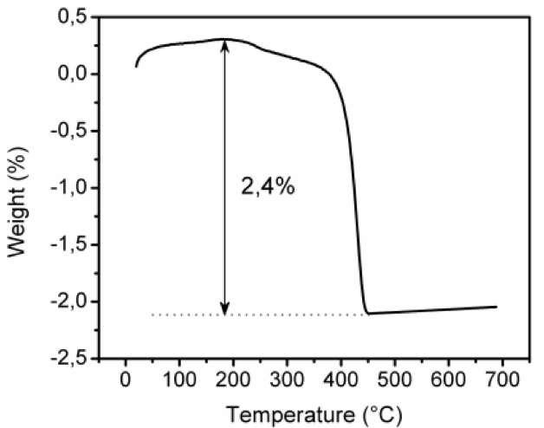
Figure 8 – TGA analysis.
With the usage of SEM and EDX analysis after sintering (reveals the dark grey phase, representing a Nd₂Fe₁₄B matrix phase (ferromagnetic), and the light gray phase is a Nd rich phase (paramagnetic), consequence of the nominal composition of the alloy.
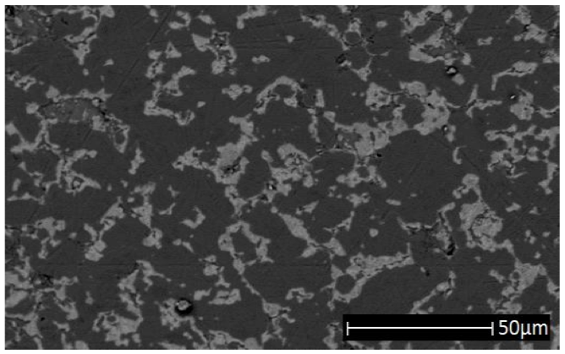
Figure 9 - Backscattered electron image of the sample.
It is known that the average grain size have clear aspects on the magnetic properties of the magnet, and it is a function of the sintering temperature and rate of heating or cooling.
The sintered part, showed on Figure 10, presented a density of 7.3 g/cm3 which correspond of 97% of the crystallographic density, and a carbon content of 0.10%, considered a small value indicating that the debinding process was effective.
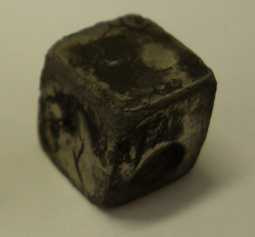
10mm
Figure 10 - Sintered sample.
In Figure 11 shows the demagnetization curves, the second quadrant of the hysteresis loop, measured on magnetically saturated samples. The big difference between the easy and hard magnetization directions (1.07 and 0.4T respectively) displays that the magnets produced are anisotropic and the magnetic field applied during injection molding has successfully align the particles.
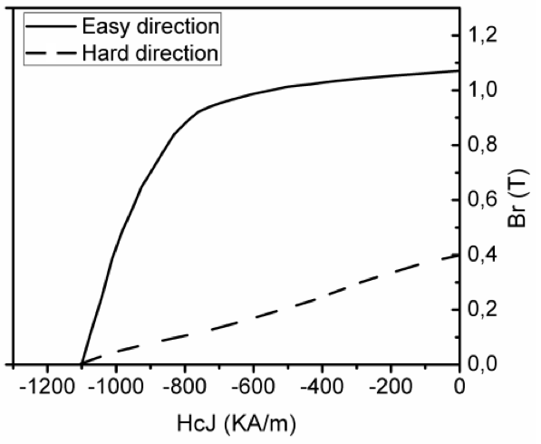
Figure 11 – Demagnetizing curve measured with the hystograph on the easy and hard magnetic directions.
As previously said, the amount of Nd rich phase threshold the remanence values reached by the magnet as this is a paramagnetic phase. The usage of other alloy compositions with lower amounts of Nd and Dy could result in high remanence values.

CONCLUSION

Powder injection molding is an alternative processing method for magnets production on complex geometries. The results presented assured that the powder particles were aligned during injection and the magnetic properties are relatively next to the traditional powder metallurgy.
Deeper studies should be taken with different nominal chemical compositions, to minimize the formation of Nd rich phases, and further compositions of the binder used to prevent the contamination with carbon.

REFERENCES

1. COEY, J. M. D.. Rare-earth Iron Permanent Magnets. New York: Oxford, 1996.
2. O`HANDLEY, Robert C.. Modern Magnetic Materials. New York: Wiley-interscience, 2000.
3. Developments in the processing and properties of NdFeB-type permanent magnets. Journal Of Magnetism And Magnetic Materials: Elsevier, 25 abr. 2002. Disponível em: <http://144.206.159.178/ft/608/72789/1244323.pdf>. Acesso em: 29 set. 2012.
4 GERMAN, Randall M.; CORNWALL, Robert G.. The powder Injection Molding Industry: an Industry and Market Report. Belmont Circle: Oxford, 1997.

