INFLUENCE OF PROCESSING CONDITIONS ON MORPHOLOGICAL, THERMAL END RHEOLOGICAL PROPERTIES OF GELATINIZED STARCH AND LOW DENSITY POLYETHYLENE BLENDS

D. Teodoro Junior¹, M. S. Coutinho², R. F. Cabral¹, L. P. da Silva¹
dermevaljunior@uezo.rj.gov.br
¹ Centro Universitário Estadual da Zona Oeste, Av. Manuel Caldeira de Alvarenga 1203, Campo Grande, Rio de Janeiro, RJ, Brasil.
² Centro Tecnológico do Exército, Av. das Américas, 28705, Guaratiba, Rio de Janeiro, RJ, Brasil.

ABSTRACT

The search for composite materials, aims on the improvement of materials and reducing the usage of non-renewable sources. This paper discusses the influence of processing conditions, on morphological, thermal and rheological properties of composite made by low-density polyethylene (LDPE) and starch. Starch was dried for 24 hours, mixed with LDPE and processed in the extruder. Processing temperatures were handled from 115 °C up to 190°C. Concerning to the composite material obtained, its morphology was evaluated by scanning electron microscopy (SEM). The Differential Scanning Calorimeter (DSC)was applied to determine melting temperature. Through rheometer, dynamic tests were performed within the linear viscoelastic region (LVR) at constant temperature of 190° C. All studied mixtures exhibited non-Newtonian flow behavior. Addition of starch affects the viscoelastic behavior of the mixtures. Results also indicated that addition of starch improved rheological and mechanical properties of LDPE / starch.

Key-words: LDPE, starch, composites, rheology.

INTRODUCTION

The search for composite materials, aims on the improvement of materials and reducing the usage of non-renewable sources. Nowadays industries have developed a special interest in environmentally friendly polymers that have good rheological and mechanical properties⁽¹⁾. This demand has led researchers worldwide, to search for polymers with biodegradable, non-toxic and recyclable features, preferably, derived from renewable resources and at low cost, in order to, ensure sustainable development⁽¹⁾. Gelatinized Starch (GS) is presented as a very interesting material, especially, due to it is inexpensive, found in abundance in nature, as a carbohydrate storage material, accumulated by green plants, in the form of granules, basically composed by two different types of polysaccharide molecules, amylose (linear) and amylopectin (branched)⁽²⁾. Although, these granules swell when they absorb water through hydrogen bonds, established with its free hydroxyl groups, they are still able to maintain order and a crystallinity, however, heating of swollen starch granules leads to a disturbing effect on hydrogen bonds, among the adjacent units of glucose thus crystallize and destroy them progressively, occurring the so-called starch gelatinization process⁽²⁾. Mixtures of starch with synthetic polymers have been extensively studied, focusing on improving both physical and mechanical properties of starch, also leading to cost reduction on final product⁽³⁾. LDPE is obtained by free radical mechanism, it is branched, has low crystallinity, molecular weight: 5x10⁴, density: 0.92 to 0.94 g/cm³, glass transition temperature (Tg): -20 ° C, melting temperature(Tm) : 120 ° C , is a thermoplastic with good mechanical properties and excellent chemical resistance, it is used as a versatile and films, packaging and transport of several materials^{(4,5)}. On the other hand, compatibility between polymers with low density, often leads to mixtures with low physical-mechanical properties⁽⁶⁾. In order to overcome these limitations, the control of processing conditions is very important to ensure interaction between GS and LDPE, aiming to achieve a behavior quite similar to conventional polymer / polymer blends.

MATERIALS AND METHODS

Starch was dried in an oven model MA 033 (Marconi - Brazil), with controlled temperature over a period of 24 hours, pellets of LDPE were mixed with starch and then processed in single screw extruder, model AX, (AX Plastic - Brazil), with the heating zones for the processing, changing from 115 ° C to 190 °C. It was used Scanning Electron Microscope (SEM), model JSN 94 LV (JEOL - Japan), to evaluate morphology of the composite. Differential Scanning Calorimeter (DSC), Model 200 F3 (NETZSCH - Germany) was used to evaluate fusion and degradation phenomena. Rheological properties of LDPE / GS were obtained from an oscillatory rheometer model MARS (Haake - Germany) using low inertia parallel plate geometry ,PP35H ceramic rod, with gap of 1.00 mm and an electrical temperature control system, UTCE / P, all dynamic tests were performed within the linear viscoelastic region (LVR) keeping temperature constant at 190 ⁰C. Frequency sweeps tests were carried out in the range of 92.22 to 0.63 rad / s.

RESULTS AND DISCUSSION

As shown in Fig. 1 (a-d) results of SEM micrographs indicate the presence of continuous morphology, which is in good agreement with the occurred compatibility between matrix and load (Fig. 1 (b)).
Fig. 1 (a-d): Micrograph of the GS structures and LDPE matrix, with different contents 1wt% GS (b) 10wt% GS (c) and 30wt% GS (d).
The test samples were sputter-coated with gold, in order to give a better view of the structures.
Increasing starch content, there was a decrease in the average particle size (Fig. 1 (c)), leading to an increase in the dispersion in the matrix of LDPE (Fig.. 1 (d)) on the other hand, coalescence on starch phase decreases. The scientific literature has shown that the average particle size is a function of the viscosity ratio of phase dispersion in the matrix. That is, in addition to interfacial tension, mixtures of viscosity, volume fraction of dispersed phase and shear rate.
Results of DSC, as shown in Fig. 2, indicated that the addition of starch, leads to a marked decrease in melting temperature, increasing as starch content increases, the same behavior was observed in the viscoelastic properties of crystallization temperature.

(a) (b)
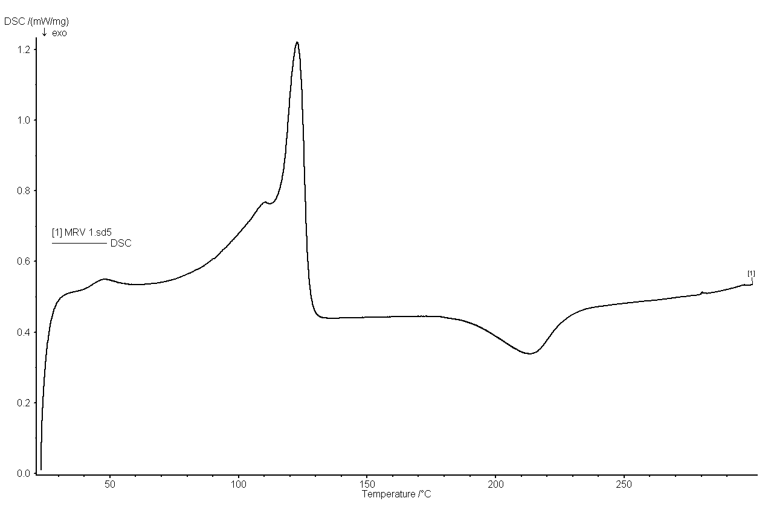
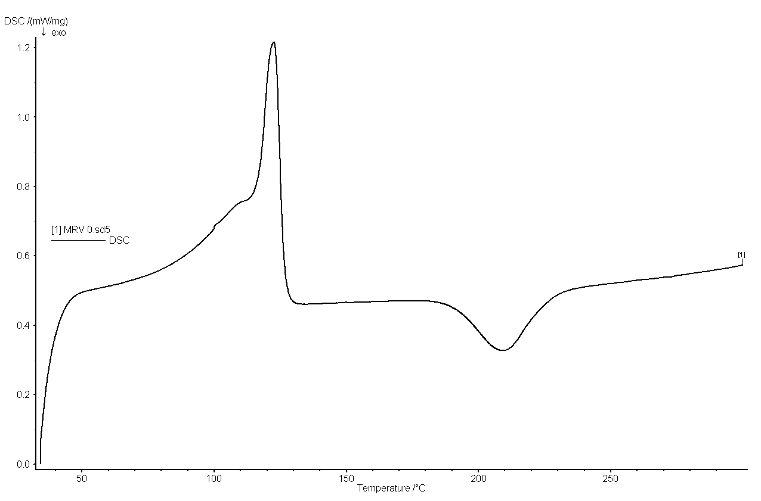
(c) (d)
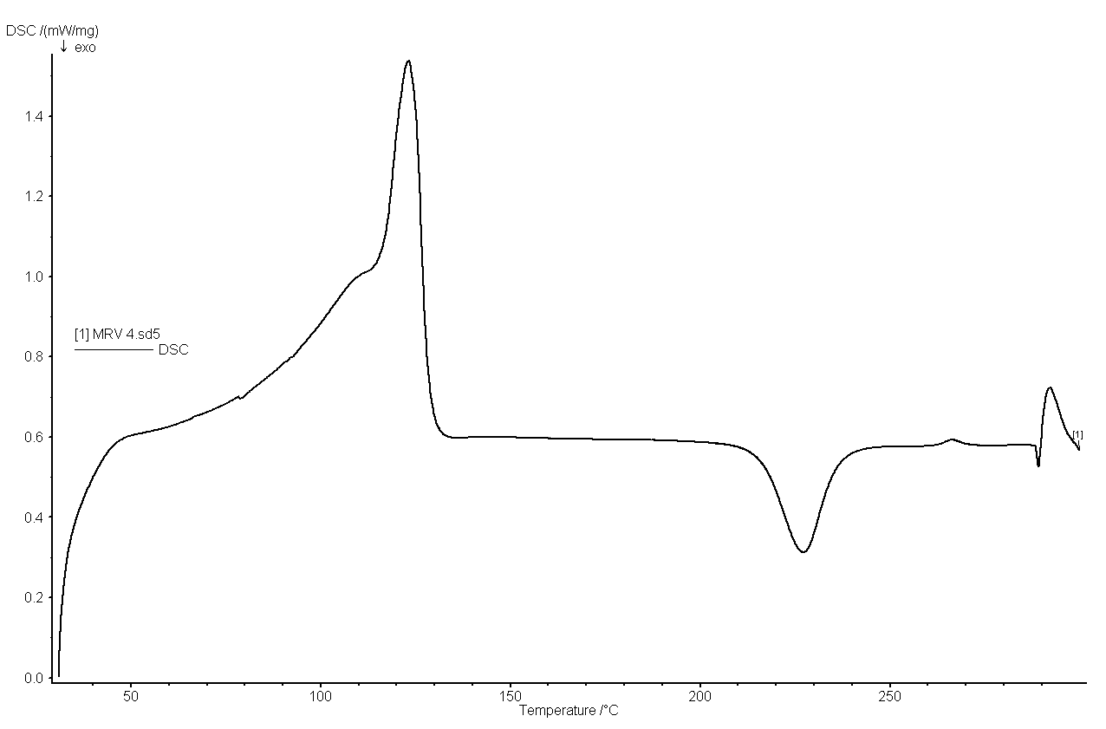
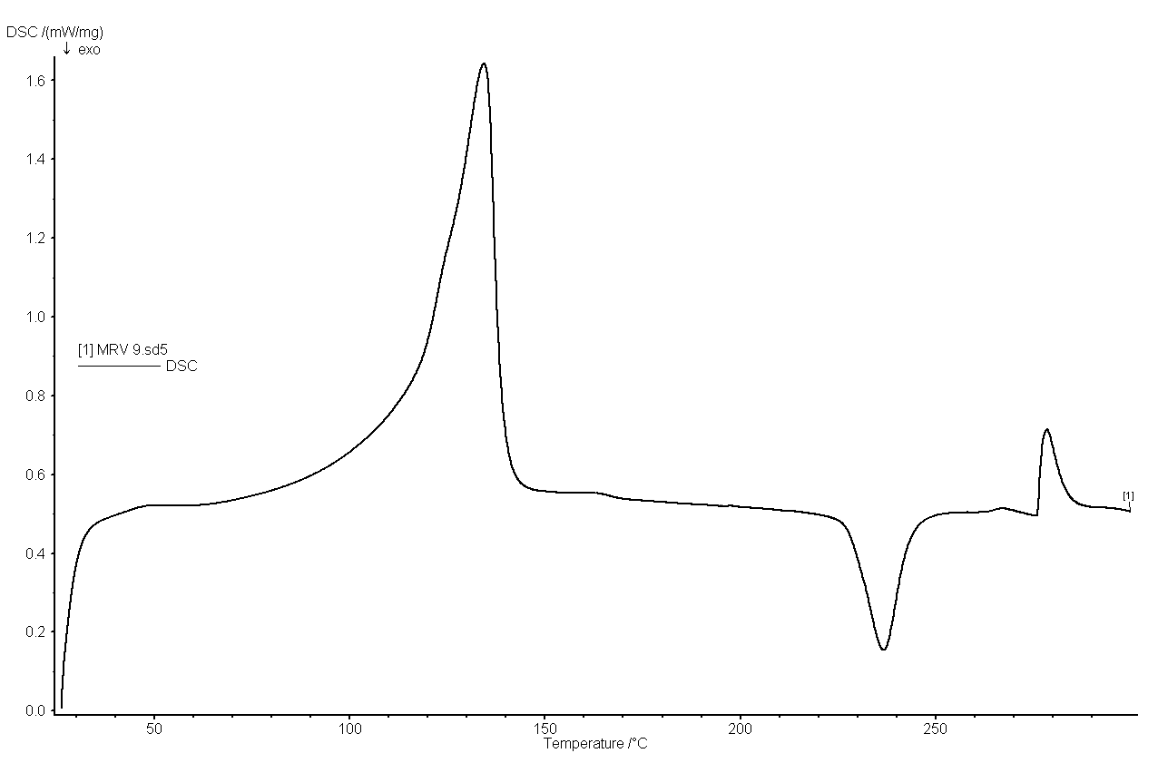

Fig. 2 (a-d): Results of DSC, mixture LDPE / GS, with 0wt% GS (a), 1wt% GS (b), 10wt% GS (c) and 30wt% GS (d).
The mixture of LDPE/GS, with different contents of starch (0, 1, 10 and 30wt%) were investigated by dynamic tests carried out within the linear viscoelastic region (LVR), with constant temperature of 190 ° C, as shown on Figs. (2-3) and Table 1.

Fig. 3 shows the dynamic tests conducted on the sample, correlating the complex viscosity as a function of angular frequency.

Fig. 3: Complex viscosity as a function of angular frequency

The Fig. 4 shows the dynamic tests conducted in the sample relating the phase angle as a function of starch content.

Fig. 4: Phase angle as a function of starch content

As shown in Tab.1, there was an increase in viscosity and the elastic recovery zero except for the composition with 1wt% of GS, indicating that the presence of starch, tends to deliver the required stability in the mixture to avoid the phenomenon of phase separation, viscosity zero shear rate is linked to the Newtonian plateau viscosity in the polymer, higher the viscosity zero shear rate value, greater is the mechanical stability of the polymer and demonstrates the increased elastic components in the mixture, the decrease of the relaxation times as a function of presence of starch is in good agreement with the observations described previously.

Table 1 - Test for Creep and Recovery of LDPE / GS

Starch Content (%) | Viscosity Zero Shear Rate (Pa.s) | Elastic Recovery (%) | RelaxationTime (s)
0 | 2,16 10E+4 | 8,35 | 49,39
1 | 1,92 10E+4 | 4,84 | 41,49
10 | 2,60 10E+4 | 12,32 | 97,85
30 | 3,25 10E+4 | 25,95 | 95,68

The storage modulus (G’) and loss modulus (G”) showed slightly frequency dependence, both modulii increased, increasing angular frequency (ω), G” magnitudes were higher than G’ magnitudes for all studied compositions, phase angle (δ) may be calculated as a ratio between G”/G’, results indicated that blend´s elasticity increased exponentially increasing starch content.

CONCLUSION

All samples exhibited non-newtonian flow behavior (shear thinning) The results showed that the addition of GS affects the viscoelastic behavior of the mixtures due to the interactions between the components in the mixture. The best properties were obtained for samples 70/30 wt% (LDPE/GS), indicating the improvement on rheological and mechanical properties of the LDPE/GS blends. The control of processing conditions allowed the development of the mixture without needing to use compatibilizer agents, both characterization techniques showed good correlation.

REFERENCES

1. SCOTT, G. Polymer and the Environment. The Royal Society of Chemistry. Lechtworth, UK, 1995.
2. BLANSHARD, J.M.V. Starch granule structure and function: a physicochemical approach, in: Starch: Properties and Potentials. Galliard. T Chichester. John-Wiley. New York, USA, 1987.
3. COUTINHO, M.S.; SILVA, D.C.F.; XAVIER, G.R.; RUMJANEK, N.G.; OLIVEIRA, P.J. Propriedades reológicas da mistura de carboximetilcelulose/amido e suas aplicações como veículo de inoculação. Anais 110 Congresso Brasileiro de Polímeros, 2011.
4. MANO, E.B.; MENDES, L.C. Introdução a Polímeros. Edgard Blücher: São Paulo, 2004.
5. PISTOR, V.; CHIESA, A.; ZATTERA, A.J. Estudo do reprocessamento de PEBD reciclado do processamento de extrusão de filmes tubulares. Polímeros, V.20 n.4, p.269-274, 2010.
6. SPINACÉ, M.A.S.; DE PAOLI, M. A. A Tecnologia da Reciclagem de Polímeros. Química Nova,Vol. 28, No. 1, 65-72, 2005.

