Integrated modelling for large-scale deployment of sustainable aviation fuels in Brazil: an induced land use change assessment

Authors. Pedro Luiz Barbosa Maia¹ (pedroluiz@ppe.ufrj.br), Gerd Brantes Angelkorte¹ (angelkorte@ppe.ufrj.br), Clarissa Bergman Fonte¹ (clarissa@ppe.ufrj.br), Clarissa de Souza Vicente¹ (souzacv@ppe.ufrj.br), Lucas Silva Carvalho¹ (lucascarvalho@ppe.ufrj.br), Taísa Nogueira Morais¹ (taisanm@ppe.ufrj.br), Ana Carolina Oliveira Fiorini¹ (acfiorini@ppe.ufrj.br), Alexandre Szklo¹ (szklo@ppe.ufrj.br), Joana Portugal-Pereira¹ (joana.portugal@ppe.ufrj.br).
¹ Centre for Energy and Environmental Economics (Cenergia), Energy Planning Program (PPE), COPPE, Universidade Federal do Rio de Janeiro, Brazil
Área 6: Biorefinaria. Sistemas integrados. Modelagem.

1 - Abstract
This work aims to assess impacts associated with the large-scale deployment of sustainable aviation fuels produced in Brazil through two standardized routes (Alcohol to Jet – ATJ and Hydroprocessed Esters and Fatty Acids - HEFA) and four different biomass feedstocks in the territory (maize – second crop harvest, sugarcane, palm and macaw fruit). To this end, the national integrated assessment model (IAM), Brazilian Land Use and Energy System (BLUES) was applied. Five self-imposed SAF market penetration shares for total kerosene demand are assessed, ranging from 10% to 50%. Induced land use change is analyzed with two approaches towards deforestation: zero illegal deforestation 2028 onwards, which reflects the Brazilian climate mitigation targets under the Paris Agreement, and high deforestation rates, following historical trends. Main findings are that 10% is the optimal share for deployment with current technologies and premises and ATJ routes show better performance in climate mitigation terms in comparison to HEFA.

Keywords: synthetic paraffinic kerosene, land conversion, integrated assessment models, aviation, Brazil, BLUES
2 - Introduction
Aviation is responsible for nearly 2% of total global CO₂ emissions and 12% of the total transport emissions (ATAG, 2020). However, the sector is hard to abate, a definition for sectors in which severe mitigation of greenhouse gases (GHG) emissions is not simple. The fact that demand is projected to grow at high rates and the absence of market ready technologies for mitigation partially explain the difficulties for a transition to low carbon economy in aviation (Sharmina et al., 2021).
Recent urgency for decarbonization is observed within the aviation industry. Both the International Civil Aviation Organization (ICAO) and the International Air Transport Association (IATA) agendas are heavily influenced by climate change mitigation, with goals of fuel burning efficiency increase in aircrafts, carbon neutral growth 2020 onwards and the implementation of the Carbon Offsetting and Reduction Scheme (CORSIA), relying heavily on the large-scale deployment of Sustainable Aviation Fuels (SAF). The broad deployment of SAFs for reducing GHG emissions is usually associated with the consumption of agriculture-based feedstock (IRENA, 2021), which needs assessment of land use change emissions.
Integrated assessment models (IAM) use quantitative descriptions of industry sectors, land and water use, among others to describe the human-earth system focusing on delivering information for stakeholders in regard to climate policies. Therefore, they may provide a better comprehension of large-scale deployment of SAF in a country, region or the globe and its associated impacts in an integrated perspective.
3 – Objectives
This work aims to assess the impacts related to planted area expansion for crop cultivation and induced land use change for different levels of SAF penetration in the Brazilian kerosene market, considering two production routes and four feedstocks.
4 - Methodology
This study assesses two routes of SAF production, namely Alcohol to Jet (ATJ) and Hydroprocessed Esters and Fatty Acids (HEFA). Sugarcane and maize (second crop harvest) were chosen as feedstock for the ATJ route, whereas palm and macaw were the oily crops for HEFA production. A sensitivity analysis on macaw palm productive assumptions was developed (“LoProd and “HiProd”), as macaw production for energy use is not yet fully established in Brazil. Six market penetration levels were analyzed, ranging from 10 to 50% of total. For increasing the robustness of results, two scenarios regarding deforestation were assessed: “Reference”, in which there are no practical restraints towards deforestation, and rates are based on historical numbers (Rochedo et al., 2018) and “ZeroDef”, which refers to the Brazilian recently announced goal of achieving zero illegal deforestation by 2028.
The Brazilian Land Use and Energy System (BLUES), a national Integrated Assessment Model, was used to evaluate these scenarios. The optimization time horizon is 2010 to 2050, with a time step of 5 years. Results focus on the accumulated values for the 2020-2050 period, for each feedstock, and the emission factors in gCO_{2eq}/MJ of fuel and land cover change in Mha.
5 – Results and discussion
The GHG emission factors analysis shows that 10% of market penetration by SAF presented the best results overall, providing the lowest, most negative values for all scenarios, ranging from -199.7 (ZeroDef, Maize) to -29.5 (Ref, Palm) gCO_{2eq}/MJ. Maize ATJ routes translate the lowest GHG emissions among all evaluated routes, followed by sugarcane. The oily crops performance results in high GHG emissions, with particularities depending on the penetration level. All ZeroDef scenarios, even at 50%, presented negative emission factors. However, regarding the Ref scenario, starting at 20% penetration, all crops but Maize were met with positive emission factors. The highest values were found on the 30% and 40% rates, depending on the crop. Palm performed comparatively worse on 20% and 30% levels, but macaw showed worse results for 40% and 50% rates.

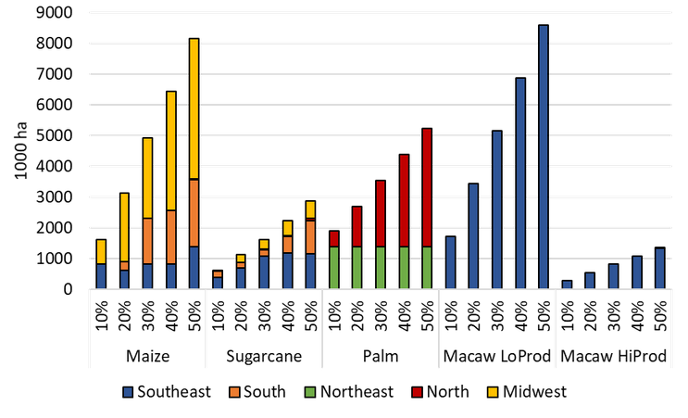
Figure 1: Planted area for crops in 2050 for Brazilian regions
Figure 1 summarizes the total planted area and its distribution throughout Brazilian regions, for each crop and different penetration levels. Maize, sugarcane and palm show expansion into different regions, while macaw is only planted in the southeast.
For induced land change, Ref scenarios with 10% penetration of SAF shows maintenance of deforestation levels for all crops compared to 0% SAF deployment, with conversion (ranging from 4 to 8 Mha) of degraded pastures to crop and ICLFc areas (Integrated Crop-Livestock-Forestry commercial). From 20% onwards, all options but maize showed native forest suppression, up to 1 Mha.
All ZeroDef scenarios showed the conversion of 20 Mha of native forest (contrasting to 74.4 to 75 Mha for Ref) independent on SAF penetration levels. Like previous analysis, 10% penetration levels show most expressive results, converting larger areas of degraded pasture to crop and ICLFc areas.
4 – Final remarks
This work evaluated the induced land use change impacts of expansion of SAF production in Brazil through the national IAM BLUES. The blend of 10% of total kerosene was found to be the optimal value regarding total life cycle GHG emissions, considering induced land use changes from feedstock production. The most competitive crop was maize (second crop harvest), followed by sugarcane, although all crops performed relatively well if anti deforestation policies are in place. Synergies were found, mainly for ATJ feedstocks, with land conversion from degraded pasture into cropland.
5 – Acknowledgements
Pedro Luiz Barbosa Maia thanks to financial support from the Human Resources Program of the National Agency of Petroleum, Natural Gas, and Biofuels - PRH-41/ANP (in Portuguese), supported with funds from the investment of oil companies qualified in the R&DI Clause of ANP Resolution 50/2015. The authors would like to thank the Brazilian Coordination of Superior Level Staff Improvement (CAPES) and the Brazilian National Council for Scientific and Technological Development (CNPq) for financial support, and the Roundtable on Sustainable Biomaterials (RSB) team for the collaboration on the study.
6 - References
ATAG. Facts & figures, 2020.
FRICKO, O. et al. The marker quantification of the Shared Socioeconomic Pathway 2: A middle-of-the-road scenario for the 21st century, Global Environmental Change, 42, 2017. p251–267.
INTERNATIONAL RENEWABLE ENERGY AGENCY (IRENA). Reaching Zero with Renewables: Biojet fuels. International Renewable Energy Agency, 2021.
ROCHEDO, P. R. R. et al. The threat of political bargaining to climate mitigation in Brazil, Nature Climate Change, 8(8), 2018. p695–698.
SHARMINA, M. et al. Decarbonising the critical sectors of aviation, shipping, road freight and industry o limit warming to 1.5–2°C, Climate Policy, 21(4), 2021. p455–474.

